WLSA Woodcliff Lake Senior Association Newsletter
December/January 2014-15 Issue
“The object of this association shall be to provide information, good fellowship and an opportunity for civic involvement for men and women fifty-five years of age and older”

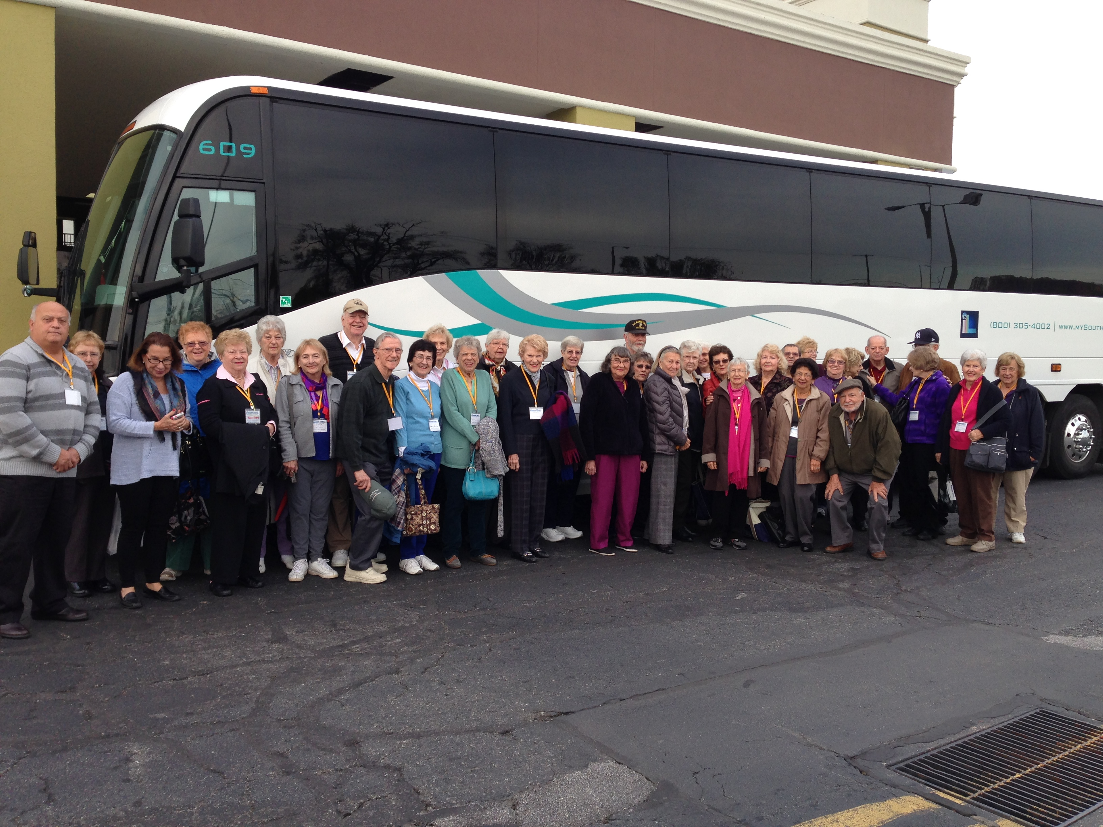

Lancaster, PA trip, October 28 – 30th, 2014


September Welcome Back Luncheon/Square Dance…

Allemande left, dosado, promenade … those words were repeated many times as the WLSA members enjoyed our first square dance at the Center. We look forward to repeating this successful event next year!

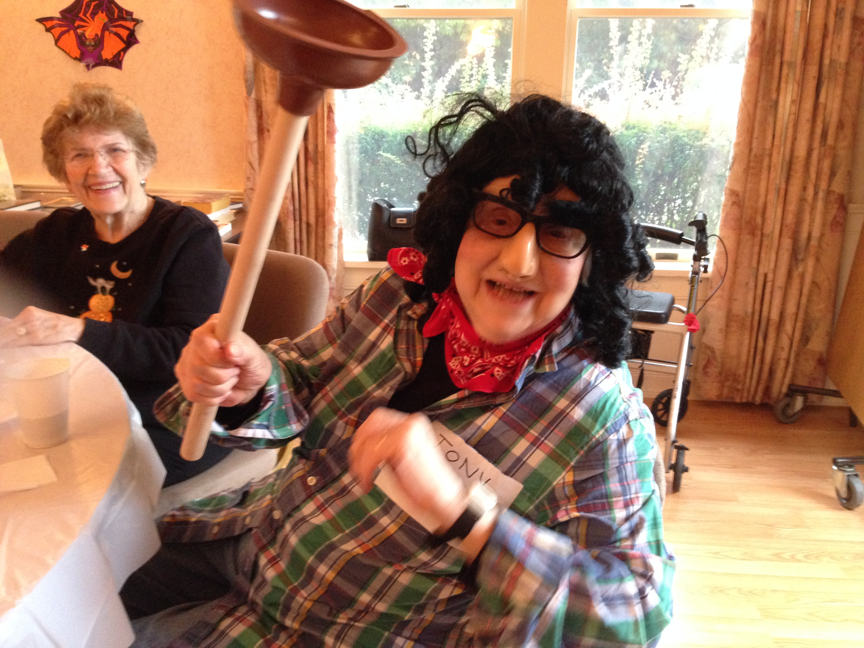
Tony the Plumber (a/k/a Ruth Daly) took first prize in the Halloween Costume contest at our October luncheon/dance!
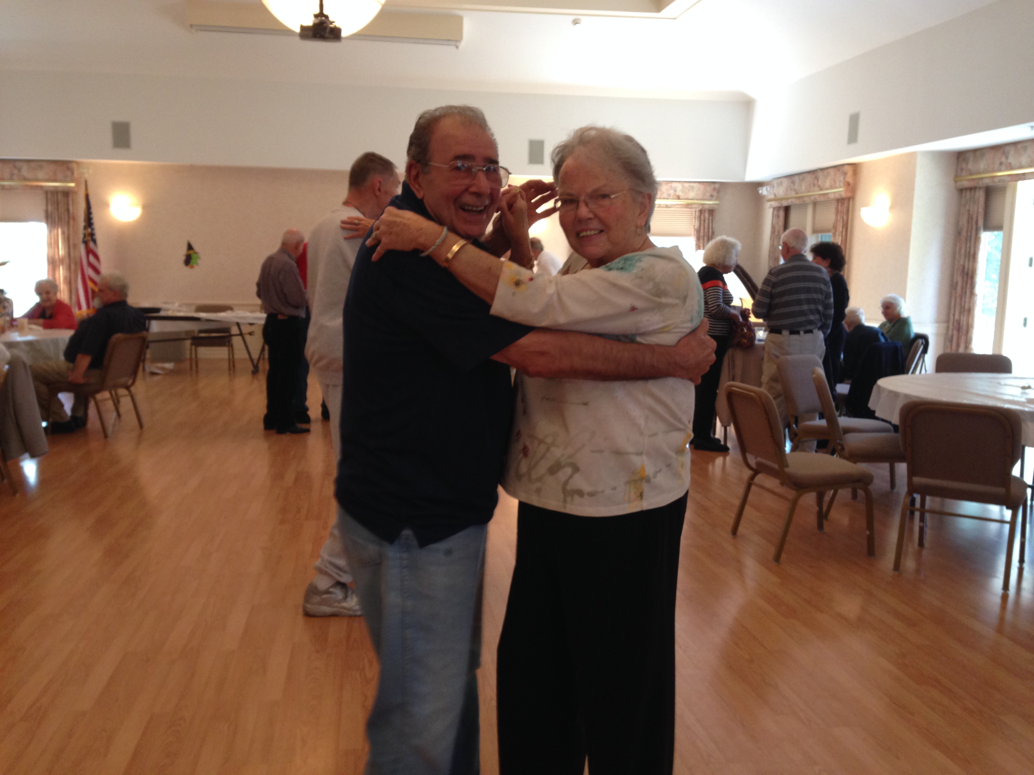

Congratulations to Annette and Sandy Alepa who celebrated their 55th wedding anniversary the same day as our Halloween Party!

Dues…

WLSA dues of $10 per year due January 1, 2015. Treasurer Lois Drobinske is taking checks now. You can also mail your check to WLSA, 188 Pascack Road, Woodcliff Lake, NJ 07677. PLEASE, do not make it necessary for the Executive Committee to make phone calls.

Water discounted rates available for Senior Citizens…

Contact the Park Ridge Water Company to explore your eligibility at 201-391-2113. You must be 65 years old and have an annual income not to exceed $26,130 (single) and $32,037 (married couple) among other requirements.

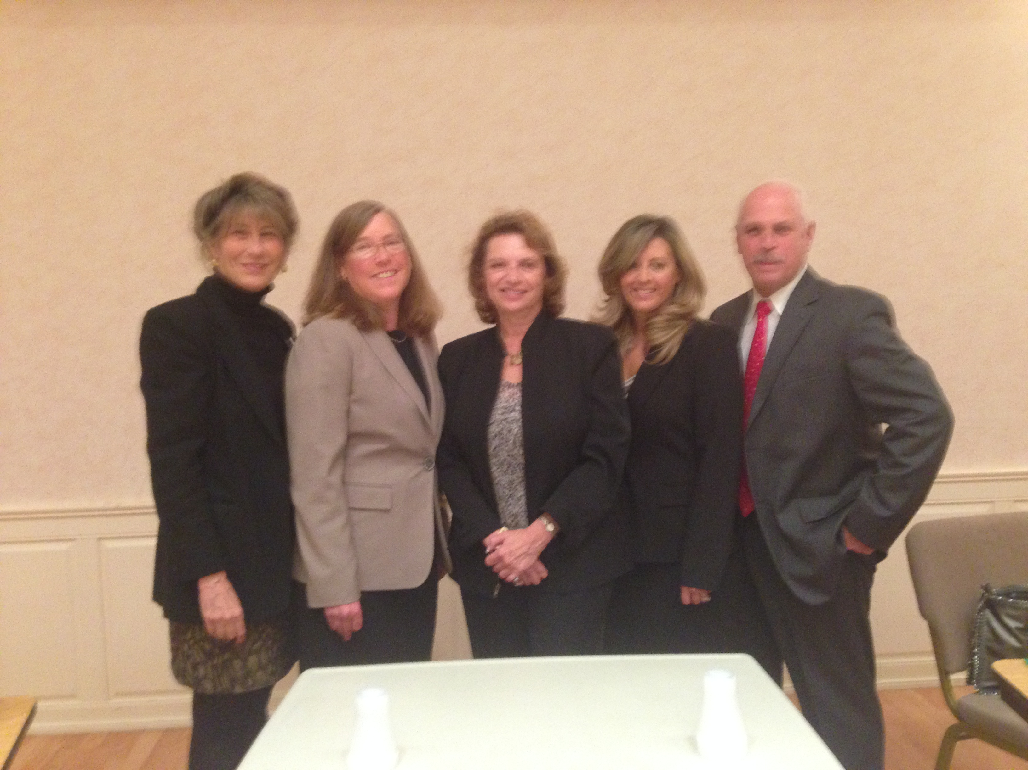
Special thanks to the WL candidates for Council for participating in Candidates’ Night October 21, sponsored by the Woodcliff Lake Senior Center and the League of Women Voters. Thanks also to the committee: Clay Bosch,
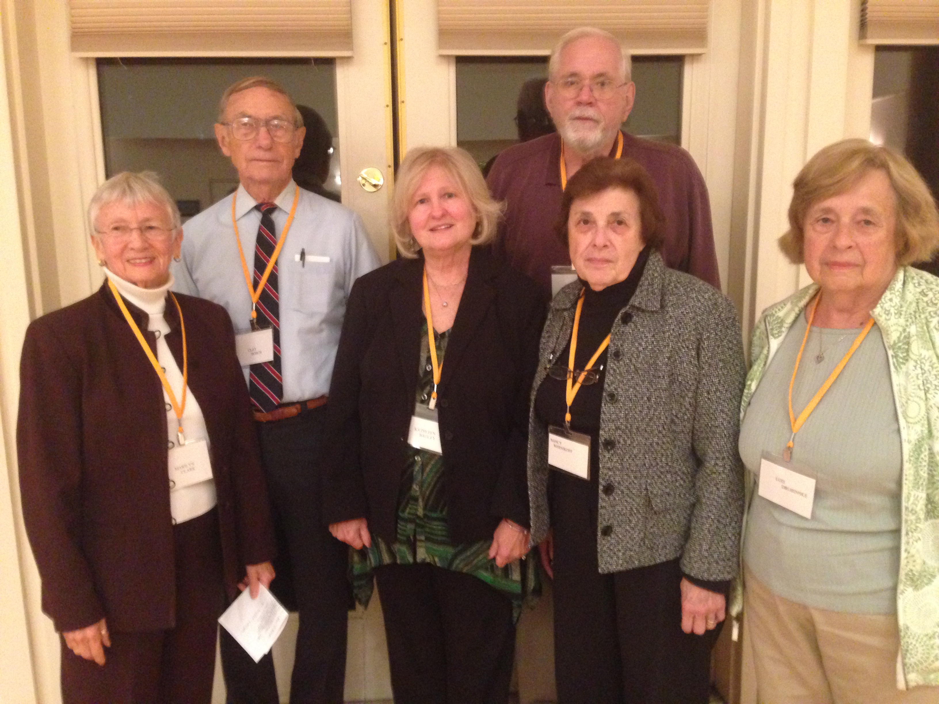
Kathleen Bagley, Marilyn Clark, Lois Drobinske, Dan McGlynn, Bert Taylor, Nancy Wernikoff, and to John DeMercurio for his help that evening.

Canasta…
The Canasta Club is established and meets each Tuesday at 2:30 p.m. Contact Carol Werba, 201-391-2713.

Lancaster/Amish Trip

Thirty-five of us toured Lancaster and the Amish Countryside and also saw the Sight and Sound show Moses. It was a great trip.

Pancake Breakfast


Thank you members of the Woodcliff Lake Police Department for hosting a great Pancake Breakfast on October 18th!

Welcoming Committee…

Ruthann Hofstetter, along with committee members Marge Coyne, Wilma Lazarus, Pat Saddle and Peg McGrath are on the newly formed Welcoming Committee.

We want everyone to feel welcome and that they know someone at the WLSA. This committee will reach out to new members.

NOMINATIONS for 2015…

Nominating chairman Ed Caso presented the slate of existing officers in nomination for 2015. After seeking nominations from the floor and none forthcoming, the slate was accepted as presented.

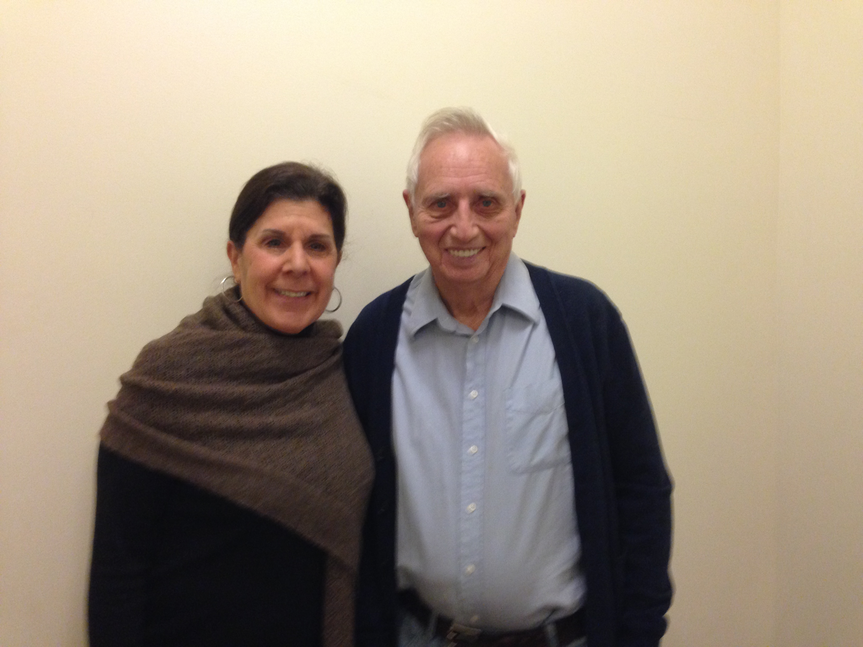
Thanks to Dr. William G. Herron for a sensitive, insightful presentation at our November 13th meeting and to Dr. Candace Schultz for arranging same.

WLSA Newsletter online…

This is how you can read the newsletter on the town website:
- Go to wclnj.com
- When the town website comes up, go to the column at the left and click on Senior Activities/Tice Center
- At the bottom of the page click on the WLSA issue of the newsletter you want to read.

In addition to being able to read it on the town website, we will email a copy to you if we have your email address. Please clearly write your email address on the information sheet available at the Tice Center or you can call Marilyn at 201-391-4720 with your email address. Thanks for your cooperation!

Welcome New Member

Ted Wallace

Best wishes to all for a GratefulThanksgiving, Merry Christmas, Happy Hanukkah, Joyful Kwanzaa and all the best for a Healthy and Happy New Year!
Marilyn(201-391-4720)

By Lois Drobinske
201-391-8574

December Birthdays

12/1 Helene Domnauer
Casey Stawicki
Lorraine Stevenson
12/5 Ronnie Boccher
Shelly Eisenberg
12/6 Agatha Johnston
12/7 Marge Coyne
12/11 Carol Werba
12/15 Lillian Corcoran
Elaine Rosenberg
12/16 Ann Biasi
Ceil Quinn
12/17 Olive Ottens
12/22 Gert Brennan
Adele Dattoli
12/24 Joseph LaPaglia
12/26 Anna Mae Marrone
12/28 Rosemary Cenicola
Kim Lam
Marge Harvey
Robert Rienecker
12/31 Lois Drobinske
Beatrice Wolf

January Birthdays

1/1 Theresa Livathares
Anthony Santulli
1/2 Daniel Kirschner
1/3 Joan Dean
1/7 Ellie Di Donato
Jeanne Werner
1/8 Connie Haddad
1/10 Joan Akerlind
Carole Nevins
1/13 Eleanor Fragiacomo
1/17 Henry Cleeff
Bill Huston
1/20 Kay Dennehy
1/21 Vicky Glaser
1/22 Ros Jacobs
1/24 Grace Chiellini
1/27 Sharon Sakowitz
1/29 Ann De Mercurio
Candace Schultz
1/30 Carol Canariato
Jeanne Ferrell
Ellen Stevens

If you know of someone who is ill or needs a note of cheer,
please contact Terry Cantone, 201-666-6749.

Interested in Yoga? Contact Nancy Wernikoff – 201-391-8376.

SENIOR VAN – Call Joy at Borough Hall, 201-391-4977, ext. 200 to schedule the Senior Van, which is available on Thursdays.

The Woodcliff Lake Seniors Book Group

Thursday, November 20th at 2 p.m. at the Tice Center, the Woodcliff Lake Book Discussion Group will meet to discuss the third volume of Ken Follette’s Edge of Eternity.

Thursday, December 18th at 2 p.m. we will discuss The Saturday’s Wife by Naomi Ragen.

At the December meeting the group will select readings for January through May. Meetings are regularly on the 4th Thursday of the month, with the exception of holidays.

Those interested in joining the group can contact Joan Caso, 201-391-3077 or wclhied@aol.com for the new spring reading list.

Looking forward to…

November 20th – 8:45 a.m. bus arrives at Old Mill and leaves at 9 a.m. for RADIO CITY MUSIC HALL arriving at 11 a.m. for the Holiday Show, lunch at Mason Sevilla at 1 p.m.

December 4th – Noon – Woodcliff Manor – Annual Holiday Party - $25

Thursday, December 18th – 12:30 – Social Meeting, December birthdays, bingo, games

January 1st – HAPPY NEW YEAR! There will be no meeting.

January 8th – Thursday at noon – Chinese Luncheon at the Tice Center - $5 – Sign up with Marge Durba

January 15th – Thursday, 12:30 – Business/Social meeting – January birthdays Josephine Higgins will make a presentation on CPR/Defib. You will have an opportunity to practice, if you like.

January 22nd – Thursday
Westchester Broadway Theater South Pacific - $58.
There are a few seats available – see Marilyn, 201-391-4720. Bus arrives at the Old Mill at 9:45 a.m. and departs at 10 a.m.

February 5th – Thursday, 12:30 - Business Meeting – Speaker t/b/a, February birthdays.

February 19th – Thursday, noon Valentine’s Day/Mock Wedding Luncheon. Dress as though you are attending a wedding reception! Shhhh…the bride and groom are a secret! Josephine Higgins, our former Mayor, will perform the ceremony. $15 to Marge Durba will reserve your spot. NO WEDDING GIFTS NECESSARY!

May … plans are underway, thanks to Sigrid Frawley, for a trip to the Brooklyn Botanical Gardens, lunch included.

June … Joyce Merlino is planning a trip to the Culinary Institute in Hyde Park. Luncheon will be in the Caterina de Medici at 12:30 p.m. … more details to come.

WLSA Officers 2015
President: Marilyn Clark
Vice-Pres.,PP: Dan McGlynn
Treasurer: Lois Drobinske
Rec. Sec.: Doris Mizzi
Corres. Sec.: Nancy Wernikoff
Past Josephine
Presidents: Higgins
Dan McGlynn
Committees - 2015

Aerobics: Helen Sochan
201-391-2581
Bingo: Joyce Merlino
201-391-2882
Book Club: Joan Caso
201-391-3077
Bridge: Lois Drobinske
(Duplicate) 201-391-8574
Ann and Sal Dell’Armo
201-391-1210
Bridge Social: Aggie Johnston
201-652-3521
Buildings & John DeMercurio
Grounds 201-573-8298
Candidates Clay Bosch
Night: 201-391-3436
Computer Dan McGlynn
Classes: 201-573-0677
Hospitality: Moria Thyne
201-391-7497
Hospitality Joan Zicchino
Host/hostesses: 201-391-2393
Library: Josephine Higgins
201-391-8622
Line Dancing: Lillian Corcoran
201-391-6715
Nominating Ed Caso
Committee: 201-391-3077
Publicity: Joyce Merlino
201-391-2882
Raffles: Anne Kineyko
Reservations Marge Durba
Luncheons: 201-391-6252
Student Aid: Fred Singer
(Honorary)
Sunshine: Terry Cantone
201-666-6749
Welcoming Ruthann Hofstetter, 201-307-0329
50/50 Anne Kineyko
201-391-2947

DO YOU HAVE ANY IDEAS TO SHARE?

- For a program
- For a trip
- For a project

Share your thoughts – we would be so happy to hear them.

Would you like to chair a committee? We would welcome you!!!

HOSPITALITY- We need your help!!!

Please call Joan Zicchino at 201-391- 2393

TRIP TO MACKINAC ISLAND, MICHIGAN

7 days, 6 nights
- Transportation
- 6 nights lodging, 4 consecutive nights in Northern Michigan
- 10 meals – 6 breakfasts, 4 dinners
- Guided tour of Mackinaw City
- Visit to Mackinac Island, including a guided carriage tour
- Boat ride through the Soo Locks and free time and sight-seeing in Sault Sainte Marie
- Visit to Mackinaw Crossings
- Admission to Colonial Michilimackinac
- And more…
Call Marilyn, 201-391-4720 if interested.

The Train of Life

At birth we boarded the train and met our parents, and we believe they will always travel by our side. However, at some station our parents will step down from the train, leaving us on this journey alone. In the meantime, other people will board the train; and they will be significant, i.e., our siblings, friends, children and even the love of our life. Many will step down and leave a permanent vacuum. Others will go so unnoticed that we don’t realize they vacated their seats. This train ride will be full of joy, sorrow, fantasy, expectations, hellos, goodbyes and farewells. Success consists of having good relationships with all passengers requiring that we give the best of ourselves. (continued on next page)

The mystery to everyone is: We do not know at which station we ourselves will step down. So, we must live in the best way; love, forgive, and offer the best of who we are. It is important to do this because when the time comes for us to step down and leave our seat empty, we should leave behind beautiful memories for those who will continue to travel on the train of life.

I wish you a joyful journey on the train of life. Reap success and give lots of love. More importantly, thank God for the journey. Lastly, I thank you for being one of the passengers on my train.
Author unknown…

WLSA CALENDAR FOR 2014-15

November 20 Thursday 9 a.m. Trip to Radio City and lunch at Mason Savilla - $81
December 4 Thursday Noon Holiday Party at the Woodcliff Manor – music
December 18 Thursday 12:30 Social Meeting – December birthdays – games, bingo
January 1 Thursday Happy New Year – no meeting
January 8 Thursday Noon Chinese Luncheon - $5 – sign up with Marge Durba
January 15 Thursday 12:30 Social Meeting – January birthdays – games, bingo
Special CPR presentation by Josephine Higgins
January 22 Thurday Westchester Broadway Theater South Pacific
February 5 Thursday 12:30 Business Meeting – Speaker t/b/a – February birthdays
February 19 Thursday Noon Valentine’s Day/Mock Wedding - $15
March 5 Thursday 12:30 Business Meeting, speaker: Bart D’Andrea– March birthdays
March 19 Thursday Noon St. Patrick’s Day Luncheon - $15
April 2 Thursday 12:30 Business meeting – Speaker t/b/a
April 16 Thursday 12:30 Social Meeting – April birthdays
May Trip to Brooklyn Botanical Gardens/lunch
May 7 Thursday 12:30 Business meeting – Speaker t/b/a
May 21 Thursday 12:30 Social Meeting – May birthdays
June Trip to Culinary Institute
June 4 Thursday 12:30 Business meeting – Speaker t/b/a - June birthdays
June 18 Thursday Noon Welcome Summer Party
THERE WILL BE NO MEETINGS IN JULY, HOWEVER ACTIVITIES WILL CONTINUE
August 6 Thursday 12:30 Business meeting – Speaker t/b/a
August 20 Thursday 12:30 Social meeting – August birthdays, games, etc.
September 3 Thursday THERE WILL BE NO MEETING
September 17 Thursday Noon Welcome Back Party
October 1 Thursday 12:30 Business meeting – speaker t/b/a – September and October birthdays
October 15 Thursday Noon Halloween Party
November 5 Thursday 12:30 Business meeting – speaker t/b/a
Election of Officers
November 19 Thursday 12:30 Social meeting – November birthdays, games, etc.
December 3 Thursday Noon Holiday Party
December17 Thursday 12:30 Social meeting – December birthdays, games, etc.

Ongoing Activities:
Aerobics – Mondays and Fridays: 9:30 – 10:30 a.m. Wednesdays: 8:30 – 9:30 a.m.
Book Club – Fourth Thursday of each month, unless otherwise noted.
Canasta Club – Tuesdays at 2:30 p.m.
Computer Classes – By appointment, contact Dan McGlynn, 201-573-0677
Duplicate Bridge - Fridays: 1 p.m.
Line Dancing - Wednesdays: 10 a.m.
Social Bridge - Mondays: 10:45 a.m.
Visiting Nurse – Third Thursday of the month, 10:30 a.m.

Business Meeting, 12:30 – 1st Thursday of each month unless otherwise noted
Social Meeting, 12:30 – 3rd Thursday of each month unless otherwise noted
Executive Meeting, 11 a.m. – 1st Thursday of each month

IF WE DO NOT HAVE YOUR EMAIL ADDRESS, PLEASE FILL OUT THE FORM BELOW:

Name_______________________________________________

Email address_______________________________@____________________

Please complete and give to either Dan or Marilyn

