WLSA Woodcliff Lake Senior Association Newsletter
July/August/September 2014 Issue
“The object of this association shall be to provide information, good fellowship and an opportunity for civic involvement for men and women fifty-five years of age and older”

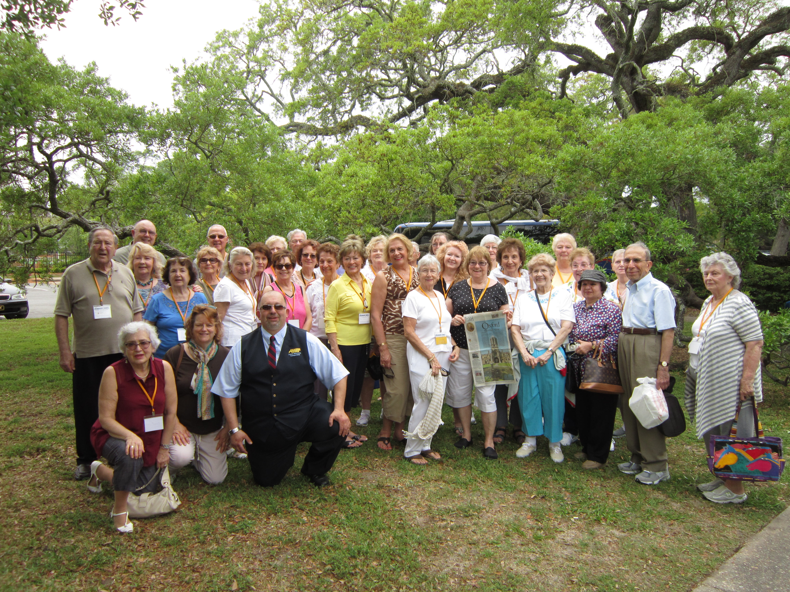

WLSA members on trip to Savannah, Georgia April 27 – May

SAVANNAH, here we come…

Seven days and six nights of sightseeing, eating, walking, hearing the history of the area and partying! What a great group to travel with.

The Parris Island visit was meaningful for Frank Capodicasa, Bern Kettler and Tom Lydon They were all stationed there, so it brought back a lot of memories.

Our first stop at the base was museum. Fortunately, most of us saw the movie and explored the major parts of the museum
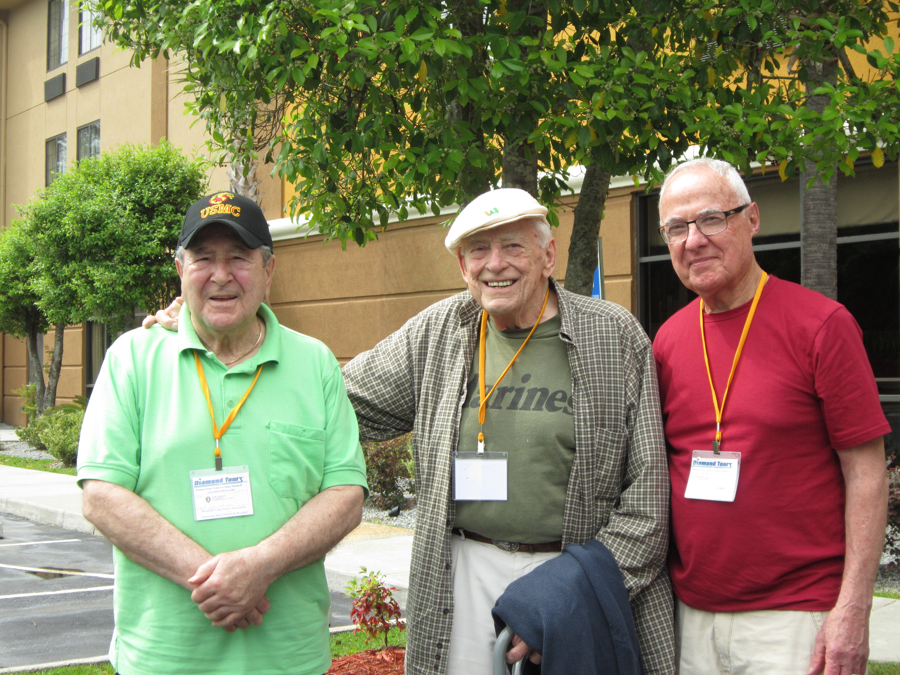
Frank, Bern and Tom

before the lights went out. It is their policy to evacuate buildings when there is no light and that is just what happened to us. Our wonderful bus driver Alec was right outside to pick us up, so everything worked out well.

AN OPPORTUNITY…

Limited to the first 25 people who sign up – we are offering the AARP Smart Driver Course at the WLSA on Wednesday, August 6th from 8:30 to 2:30. By taking this course you can get a discount on your car insurance and remove up to two points on your license.

If interested, sign up immediately with Marilyn. Make your check payable to AARP in the amount of $15 and on the memo line write your AARP number. The checks are due at the time you register. This is a great opportunity to take this course close to home.

SOMETHING NEW…

Actually, it is not so new. Our WLSA Newsletter has been on line for over a year. This is how you can read it on the town website:
- Go to wclnj.com
- When the town website comes up, go to the column at the left and click on Senior Activities/Tice Center
- At the bottom of the page click on the WLSA issue of the newsletter you want to read.

We are in transition as to how we are distributing our newsletter. In addition to being able to read it on the town website, we will email a copy to you if we have your email address. Please clearly write your email address on the information sheet available at the Tice Center or you can call Marilyn at 201-391-4720 with your email address. Thanks for your cooperation!

Bergen County Senior Golden Key Program
At our May 15th meeting, many seniors participated in the
Golden Key Photo Card
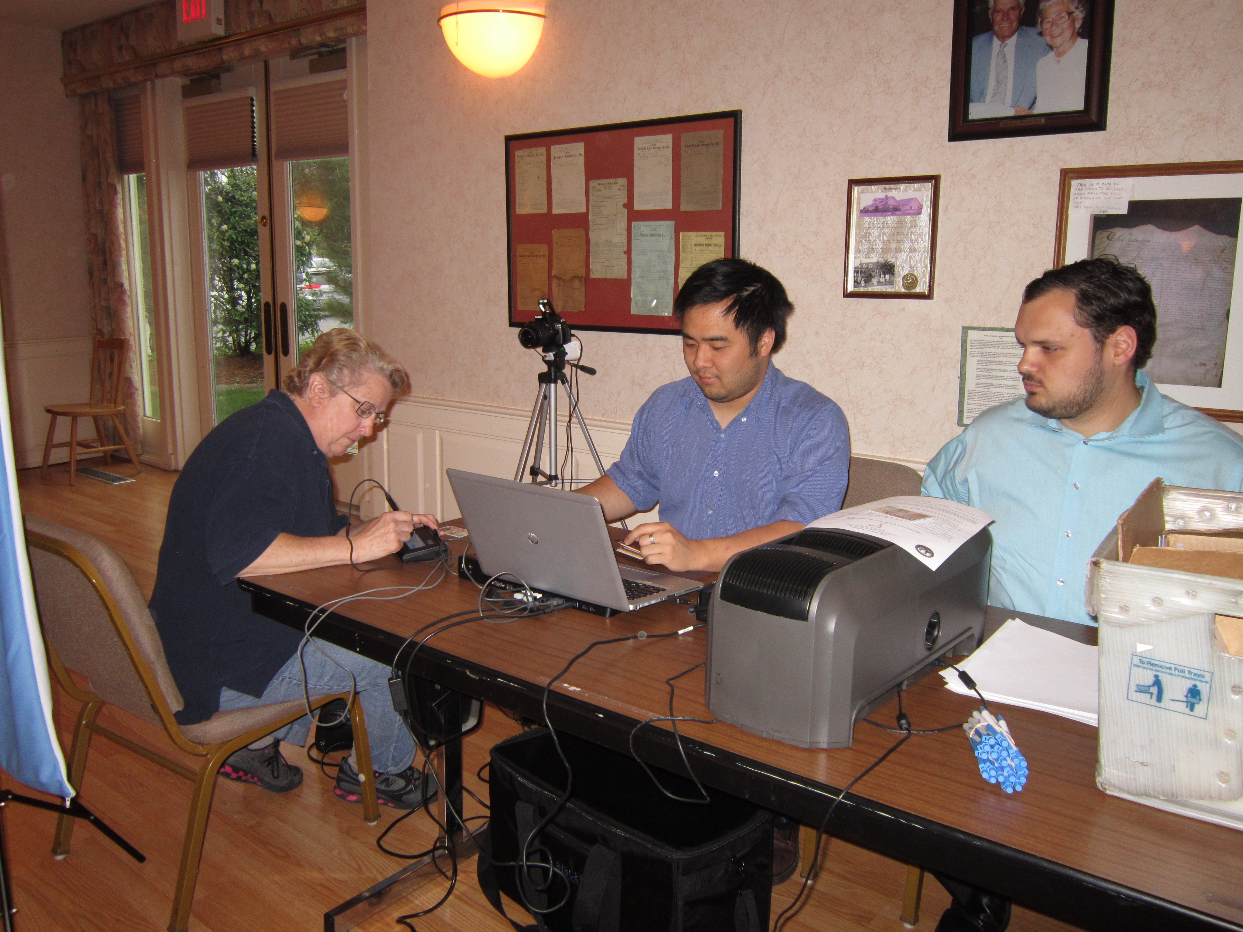
program from the Bergen County Clerk’s Office. The wallet sized photo card can be used at participating businesses and organizations offering discounts to senior.

Some of the participating companies: Applebees, Chick-Fil-A, Dennys, Dunkin Donuts, IHOP, KFC, Pizza Hut, Taco Bell, Dress Barn, Home Depot, Lowes, etc.

Medicare Preventive Tips

Medicare Part B pays for preventive care to help you stay healthy. Talk to your doctor to see if these benefits are right for you.

Questions: Call 1-800-792-8820
or visit www.aging.nj.gov
You can also contact the Bergen County SHIP office for additional information at 201-336-7413.

Thank you to Fred Messner for a wonderful June program. We all had a great time with the sing-along he planned for us.

Also at our June meeting scholarship checks were presented to Anna Alonso and Alexa Hirschberg, who are graduating seniors. Congratulations!

Welcome New Members
Sigrid Frawley
Erika Fusco
Kim Lam
Gunther McKeown
Barry Sakowitz
Audrey L. Stober
Liudmyin Vlasenko

Happy Summer!
Marilyn(201-391-4720)

In Loving Memory of :

John L. Daly

By Lois Drobinske
201-391-8574

July Birthdays

7/1 Roberta Green
Jim Horris
7/3 Helen Moore
7/5 Barry Sakowitz
7/6 Michael Rider
7/9 JoAnn Brody
7/10 Helen Gulamerian
7/11 Mauro Cappitella
Joseph Dispoto
Carol Mogolinski
7/13 Stanley Fedison
Sue Lundy
7/14 Lynn Gligor
Jan Hinch
7/15 Lee Shue
7/16 Josephine Botta
7/18 Frances Walter
7/19 Leslie Maltz
7/25 Adele DeSande
7/26 Julie Chen
7/27 Abdol Modjarrad
7/28 Tommie Ahrens

August Birthdays

8/4 Grace Hagopian
8/7 George Rice
8/11 Sigrid Frawley
Frances Setti
8/12 Suzi Gerace
Charlotte Stong
8/13 Jackie Franzel
8/17 Ethel Frey
8/18 Andrew Lukac
Liudmyin Vlasenko
8/19 Marie Gadd
8/23 William Curran
8/26 Jeanette Hoffman
Noreen Siegelbaum
8/28 Henry Zicchino
8/29 Ken Herr
8/30 Robert Cross
8/31 Natalie Effron

September Birthdays

9/1 Harry Anderson
Mary DiSpirito
9/2 Larry Brennan
Catherine Eustace
Cathy Roy
John Tosloskie
9/3 Hannelore Hahn
9/4 Jeff Bader
Cathy Barnett
Pat Carroll
9/7 Rosa Asaf
9/9 Lily Shue
9/10 Gloria Hulit
9/11 Midge Coleman
9/13 Walter Winfield
9/14 Ronnie Benstock
Elise Hirshberg
9/15 Joan Cunniffe
9/16 Marilyn Clark
Joan Zicchino
9/18 Harold Effron
Elizabeth Turner
9/19 Bern Kettler
9/20 John Tornell
9/22 Dottie Scatigno
9/23 Zahra Mohaya
Jackie Reichart
9/29 Margaret Dougherty
Carol Huston
Joyce Waldron
9/30 George Catherwood
Annelies Petri

If you know of someone who is ill or needs a note of cheer,
please contact Terry Cantone, 201-666-6749.

Speedy recovery to:
Joan Dean
Jane Ghiringhelli
Grace Hagopian
Jim Horris
Ronnie Kornberger

SENIOR VAN – Call Joy at Borough Hall, 201-391-4977, ext. 200 to schedule the Senior Van, which is available on Thursdays.

The Woodcliff Lake Seniors Book Group

Contact Joan Caso, 201-391-3077 or wclhied@aol.com if you wish to be on the Book Club Reminder email list. We welcome everyone to the discussions.

Edge of Eternity Ken Follette for September 25th meeting.

Summer Reading List:

Next to Love – Ellen Feldman
The Saturday Wife – Naomi Ragen
Doc Mary Doria Russell (His.Western)
The Glass Castle Jeanette Walls
Snow Flower and the Secret Fan Lisa See
The Widow’s Tale Mick Jackson
The Cook Book Collector Alegra Goodman
The Forgotten Garden Kate Morton
Jacob’s Daughter Samatha Fillian Bayans
The Fifth Witness Michael Connely
The Caliper’s Secret
The Johnstown Flood David McCullough
John Adams David McCullough
Mrs. Lincoln Catherine Clinton
Catherine the Great
The Marriage Plot Jeffery Engendas
The Weight of Water Anita Shreve
Wild Cheryl Stayed
The North River Pete Hamill
The No. 1 Ladies Detective Agency Alexander McCall Smith

Looking forward to…

Thursday, June 19th – Noon – Summer Sizzler – Chicken, salads, coffee, cake, beverages – music by Doug - $10 – reservations to Marge Durba.

Thursday, June 26th – 12:30 bus leaves Woodcliff Lake for Hudson River Cruise. $28, includes cruise and box lunch. Call Joyce Merlino, 201-391-2882.

THERE WILL BE NO MEETINGS IN JULY BUT ACTIVITIES WILL CONTINUE TO TAKE PLACE AT THE CENTER.

Wednesday, August 6th – 8:30 – 2:30 – AARP Smart Driver Course. $15 to AARP members. Register with Marilyn 201-391-4720.

Thursday, August 7th – 12:30 – Business Meeting – Program by Cheryl DeMallie, Nancy Wernikoff and friends. This is a not to be missed program when they will show their dogs. Cheryl’s dog is a nationwide winner!

INTRODUCTORY BRIDGE COURSE BEING OFFERED

Wilma Lazarus is offering introductory bridge classes on: August 11, 18 and 25th and September 8, 22, 29 and October 6 and 20th. If interested, please call Wilma at 201-391-9195 as soon as possible as space is limited!

This is a great opportunity to get started with bridge!

Thursday, August 21st – 12:30
Social Meeting, Games, Bingo, July and August birthdays.

There will be no meeting the 1st Thursday in September.

September 18th – Noon – Welcome Back!!!!
Square Dance!!!! Come in jeans! First we’ll have antipasto, then a round of dancing. Next, assorted sandwich followed by another round of dancing. Coffee and cake will end the afternoon with a final round of dancing. $5 per person to Marge Durba, 201-391-6252. It should be a fun afternoon!

Thursday, October 2nd – 12:30 Business meeting – Kevin Woyce who will speak about The Great Falls of Paterson. We’ll also celebrate September and October birthdays!
Thursday, October 16th – Noon – Italian Festival/Halloween Party. Music by Doug - $15 – rsvp to Marge Durba.

Tuesday, October 28 to Thursday, October 30th – Lancaster Show Trip and the Dutch Country: Motorcoach transportation, 2 nights lodging, 4 meals – 2 breakfasts, 2 dinners, “Moses” Show at the Sight & Sound Millennium Theatre, Guided Tour of Lancaster, including Amish country, visit to Kitchen Kettle Village, admission to Mennonite Information Center, admission to Landis Valley Museum & Village and more…$275, which includes gratuities. Call Marilyn – 201-391-4720 to reserve your place.

The flyer is included with this mailing.

WLSA Officers 2014
President: Marilyn Clark
Vice-Pres.,PP: Dan McGlynn
Treasurer: Lois Drobinske
Rec. Sec.: Doris Mizzi
Corres. Sec.: Nancy Wernikoff
Past Josephine
Presidents: Higgins
Dan McGlynn
Committees - 2014

Aerobics: Helen Sochan
201-391-2581
Bingo: Joyce Merlino
201-391-2882
Book Club: Joan Caso
201-391-3077
Bridge: Lois Drobinske
(Duplicate) 201-391-8574
Ann and Sal Dell’Armo
201-391-1210
Bridge Social: Aggie Johnston
201-652-3521
Buildings & John DeMercurio
Grounds 201-573-8298
Candidates Clay Bosch
Night: 201-391-3436
Computer Dan McGlynn
Classes: 201-573-0677
Hospitality: Moria Thyne
201-391-7497
Hospitality Joan Zicchino
Host/hostesses: 201-391-2393
Library: Josephine Higgins
201-391-8622
Line Dancing: Lillian Corcoran
201-391-6715
Nominating Ed Caso
Committee: 201-391-3077
Publicity: Joyce Merlino
201-391-2882
Raffles: Anne Kineyko
Reservations Marge Durba
Luncheons: 201-391-6252
Student Aid: FredSinger
(Honorary)
Sunshine: Terry Cantone
201-666-6749
50/50 Anne Kineyko
201-391-2947

DO YOU HAVE ANY IDEAS TO SHARE?

- For a program
- For a trip
- For a project

Share your thoughts – we would be so happy to hear them.

Would you like to chair a committee? We would welcome you!!!

HOSPITALITY- We need your help!!!

August 7th:

August 20th:

October 2nd:

November 6th:

November 20th:

December 18th:

Please call Joan Zicchino at 201-391- 2393

WLSA CALENDAR FOR 2014

June 19 Thursday Noon Senior Summer Sizzler – Music -
JULY NO MEETINGS
August 7 Thursday 12:30 Business Meeting Program: Cheryl DeMallie, Nancy Wernikoff and
“Friends”
August 21 Thursday 12:30 Social Meeting – July and August birthdays
September4 Thursday NO MEETING
September 18 Thursday Noon Welcome Back – Square Dance/luncheon –$5
October 2 Thursday 12:30 Business Meeting – Kevin Woyce – The Great Falls of Paterson–
September and October Birthdays
October 16 Thursday Noon Halloween Party with costumes and music – Italian luncheon - $15
October 21 Tuesday 7 p.m. Candidates’ Night
November 6 Thursday 12:30 Business Meeting - Elections – Bart D’Andrea – Post Impressionism
November 20 Thursday 12:30 Social Meeting – November birthdays – Speaker: Dr. William G. Herron,
Navigating the Golden Years - games, bingo
December 4 Thursday Noon Holiday Party at the Woodcliff Manor – music
December 18 Thursday 12:30 Social Meeting – December birthdays – games, bingo

Ongoing Activities:
Aerobics – Mondays and Fridays: 9:30 – 10:30 a.m. Wednesdays: 8:30 – 9:30 a.m.
Book Club – Fourth Thursday of each month, unless otherwise noted.
Computer Classes – By appointment, contact Dan McGlynn, 201-573-0677
Duplicate Bridge - Fridays: 1 p.m.
Line Dancing - Wednesdays: 10 a.m.
Social Bridge - Mondays: 10:45 a.m.
Visiting Nurse – Third Thursday of the month, 10:30 a.m.

Business Meeting, 12:30 – 1st Thursday of each month unless otherwise noted
Social Meeting, 12:30 – 3rd Thursday of each month unless otherwise noted
Executive Meeting, 11 a.m. – 1st Thursday of each month

IF WE DO NOT HAVE YOUR EMAIL ADDRESS, PLEASE FILL OUT THE FORM BELOW:

Name_______________________________________________

Email address_______________________________@____________________

Please complete and give to either Dan or Marilyn

